7 Speed fan

Members Name

Sadman Alam ID: 1610544042

Tarak Mahmud ID: 1520198642

Tazbin Hossain Zadid ID: 1520683042

Moddasir Ahmed Fahim ID: 1521463642

North South University

CSE 231 – Digital Logic Design

# Abstract

There is so much hot usually during the summer season of our country. Everybody uses fans or air conditioners for getting relief. But air conditioners are more expensive; as a result everyone can’t afford that. So, fan is used by most of the people. In this Digital Logic Design project we will build a 7-speed fan with logic gates IC and flip-flops. The project will show a certain speed number on the seven segment display and also the corresponding LED will be on and the fan will operate according to that certain speed.

Table of Contents

Abstract 1

Introduction…………………………………………………………………………2

Background…………………………………………………………………………………………………………3

Design Methodology………………………………………………………………………………………......4

Result & Discussion………………………………………………………………………………………………8

Conclusions………………………………………………………………………………………………………….8

References……………………………………………………………………………………………………………8

# 

# Introduction

The name of our Digital Logic Design Project is 7-Speed fan. There will be three inputs in our project. The inputs are binary values. Suppose the inputs are A=1, B=1, C=0 then it will work for binary number ‘110’ and we know what’s the decimal value for that particular binary number. It is 6. So, the seven segment display will show 6 and the no. 6 LED will be on and the rest of the LEDs will remain off. Then the fan will operate according to that speed 6. Like that there will be total of 7 scenarios. For speed indication we are using 7 segment display for showing numbers 1 to 7 and 7 LEDS.  
  
In this Digital Logic Design project we will have to build a combinational circuit as well as a sequential circuit. We will use basic gates for implementing the combinational part of our project and we will use JK flip flops for implementing the sequential part of our project. Our project will be completed by combining these two parts.

# 

# Background

In our 7-speed fan project we will use many instruments. They are:  
1) IC 7408 (2 input AND gate) X 4  
2) IC 7432 (2 input OR gate) X 2  
3) IC 7404 (2 input NOT gate) (only for combinational part, will be removed after implementing the sequential part)  
4) IC 7411 (3 input AND gate) X 2  
5) IC 4075 (3 input OR gate) X 2   
6) IC 7473 (Dual JK Flip Flops) X 2  
7) 555 timer (for clock pulse)  
8) Seven segment display (Common cathode)  
9) LED X 7  
10) Wires  
11) Resistors (100 ohm)  
12) Battery (9V)

Alongside these instruments we have used some theorical knowledge. For designing our project we have used the knowledge of Boolean Algebra, Truth Table, Karnaugh-Maps, JK Flip-Flops, State Table, State Diagram etc. So, those are ideas behind our project.

# 

# Design Methodology

This project is about displaying digits 1 to 7 for indicating the speeds of the fan. Also the corresponding number will be shown in the LED. First, we have to the combinational part after that we have to do the sequential part.

**Combinational Part:**

|  |  |  |  |  |  |  |  |  |  |  |  |  |  |  |  |  |
| --- | --- | --- | --- | --- | --- | --- | --- | --- | --- | --- | --- | --- | --- | --- | --- | --- |
| A | B | C | a | b | c | d | e | f | g | S1 | S2 | S3 | S4 | S5 | S6 | S7 |
| 0 | 0 | 0 | 1 | 1 | 1 | 1 | 1 | 1 | 0 | 0 | 0 | 0 | 0 | 0 | 0 | 0 |
| 0 | 0 | 1 | 0 | 1 | 1 | 0 | 0 | 0 | 0 | 1 | 0 | 0 | 0 | 0 | 0 | 0 |
| 0 | 1 | 0 | 1 | 1 | 0 | 1 | 1 | 0 | 1 | 0 | 1 | 0 | 0 | 0 | 0 | 0 |
| 0 | 1 | 1 | 1 | 1 | 1 | 1 | 0 | 0 | 1 | 0 | 0 | 1 | 0 | 0 | 0 | 0 |
| 1 | 0 | 0 | 0 | 1 | 1 | 0 | 0 | 1 | 1 | 0 | 0 | 0 | 1 | 0 | 0 | 0 |
| 1 | 0 | 1 | 1 | 0 | 1 | 1 | 0 | 1 | 1 | 0 | 0 | 0 | 0 | 1 | 0 | 0 |
| 1 | 1 | 0 | 1 | 0 | 1 | 1 | 1 | 1 | 1 | 0 | 0 | 0 | 0 | 0 | 1 | 0 |
| 1 | 1 | 1 | 1 | 1 | 1 | 0 | 0 | 0 | 0 | 0 | 0 | 0 | 0 | 0 | 0 | 1 |
|  |  |  |  |  |  |  |  |  |  |  |  |  |  |  |  |  |

**The K-maps(For Combinational Part):**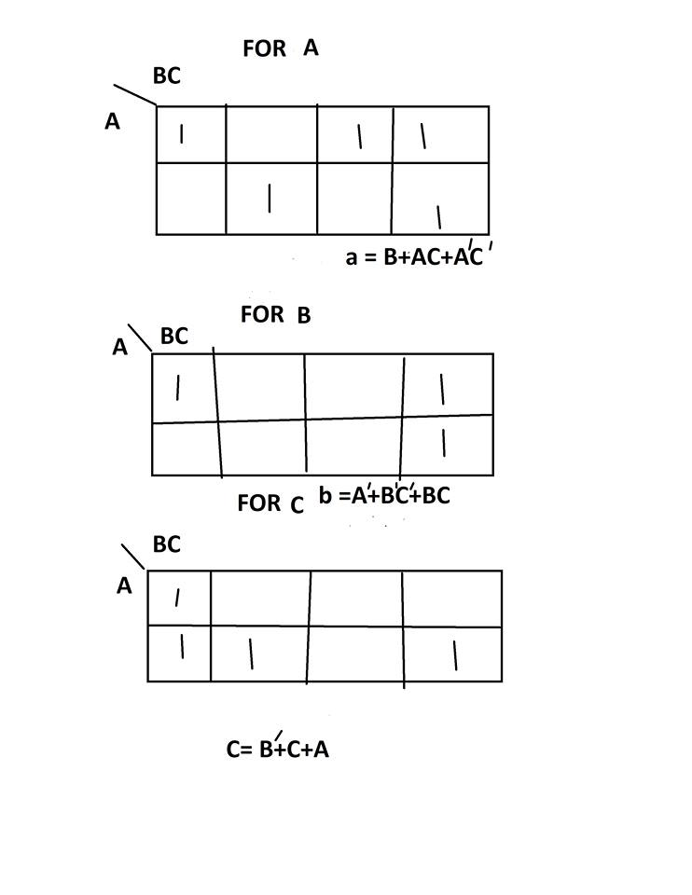

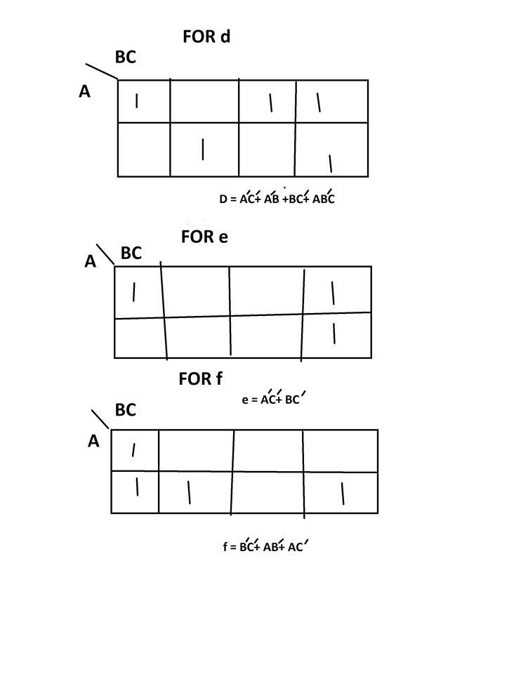

# 

**Sequential Part:**

We have used a binary counter. We have used an extra input x with the Flip-Flop inputs.  
We have 8 states here. When x=0 the state remains unchanged but when x=1 state travels to the next state. Suppose, the present state is 000. If x=0 the next state will be 000 and if x=1 then next state will be 001. This process will go on for all the states.   
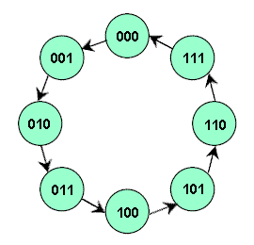

State diagram for binary up counter.

|  |  |  |  |  |  |  |  |  |  |  |  |  |
| --- | --- | --- | --- | --- | --- | --- | --- | --- | --- | --- | --- | --- |
| A | B | C | X | At+1 | Bt+1 | Ct+1 | JA | KA | JB | KB | JC | KC |
| 0 | 0 | 0 | 0 | 0 | 0 | 0 | 0 | x | 0 | x | 0 | x |
| 0 | 0 | 0 | 1 | 0 | 0 | 1 | 0 | x | 0 | x | 1 | x |
| 0 | 0 | 1 | 0 | 0 | 0 | 1 | 0 | x | 0 | x | x | 0 |
| 0 | 0 | 1 | 1 | 0 | 1 | 0 | 0 | x | 1 | x | x | 1 |
| 0 | 1 | 0 | 0 | 0 | 1 | 0 | 0 | x | x | 0 | 0 | x |
| 0 | 1 | 0 | 1 | 0 | 1 | 1 | 0 | x | x | 0 | 1 | x |
| 0 | 1 | 1 | 0 | 0 | 1 | 1 | 0 | x | x | 0 | x | 0 |
| 0 | 1 | 1 | 1 | 1 | 0 | 0 | 1 | x | x | 1 | x | 1 |
| 1 | 0 | 0 | 0 | 1 | 0 | 0 | x | 0 | 0 | x | 0 | x |
| 1 | 0 | 0 | 1 | 1 | 0 | 1 | x | 0 | 0 | x | 1 | x |
| 1 | 0 | 1 | 0 | 1 | 0 | 1 | x | 0 | 0 | x | x | 0 |
| 1 | 0 | 1 | 1 | 1 | 1 | 0 | x | 0 | 1 | x | x | 1 |
| 1 | 1 | 0 | 0 | 1 | 1 | 0 | x | 0 | x | 0 | 0 | x |
| 1 | 1 | 0 | 1 | 1 | 1 | 1 | x | 0 | x | 0 | 1 | x |
| 1 | 1 | 1 | 0 | 1 | 1 | 1 | x | 0 | x | 0 | x | 0 |
| 1 | 1 | 1 | 1 | 0 | 0 | 0 | x | 1 | x | 1 | x | 1 |

# Results & Discussion

After finishing all he calculations we have designed the circuit by using logisim.

That is attached with the project. Then we have implemented according to the diagram.

# Conclusions

At the end of the report, all we want to say that we have learned a lot and we had a lot of fun in building this project. In the theory class, we learned about combinational logic design and sequential logic design. We have used our knowledge and implemented our project which is a 7-speed fan.

# References

https://www.google.com/search?q=state+diagram+of+3+bit+up+counter&tbm=isch&source=iu&ictx=1&fir=mwu2YBc88VvKDM%253A%252CR5nBMjTck6og3M%252C_&usg=AI4_-kSMYY9ebMy22lm1KiUYxHY21vXzGQ&sa=X&ved=2ahUKEwin5rvTtL_fAhUE5o8KHdMMB6wQ9QEwAnoECAQQCA#imgrc=mwu2YBc88VvKDM: